2019

OJDDA Cornhole Benefit Tournament Registration

Stanton Park Sunday, September 15, 2019

1540 Stanton Park Rd. Start time: 1:00 pm

Canyonville, OR 97470 Rules: American Basic Cornhole Association Rules

Host: Andrea VanAuker & Jessi Watkins

Email: Andrea: avanauker@co.josephine.or.us

Jessi: jewatkins@co.josephine.or.us

Cornhole Registration Deadline: Friday August 30, 2019
(Note: You will not be registered until payment is received with this registration form)

Team Name: _______________________________________________
Player 1: __________________________________________________
Player 2: __________________________________________________
Cost per team: $40.00 ………………… Cornhole Tournament prizes will be handed out at banquet.

_____ I am not part of a team. Please put me together with other players without a team.

Make Checks Payable to: OJDDA
Mail your checks to:
OJDDA- Debra Patterson
305 NE 3rd. St.
Prineville, OR 97754
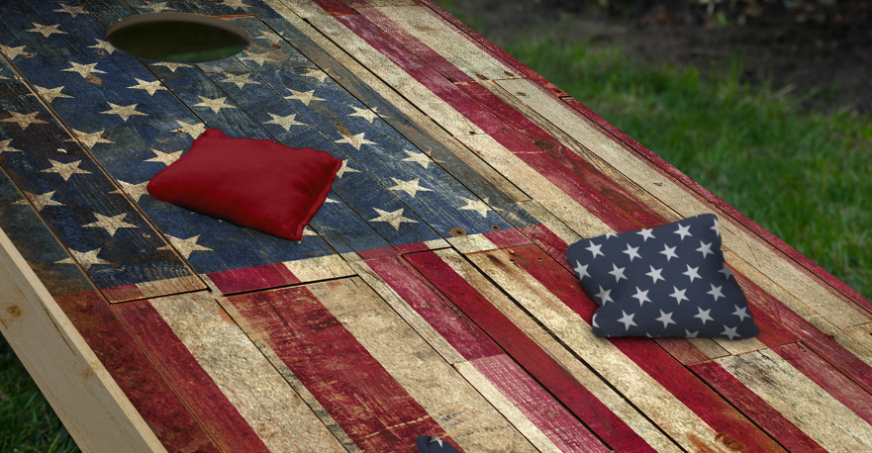

A portion of the proceeds will be donated to a local school in Douglas Co.

